**Unique Paths:**

A robot is located at the top-left corner of a m x n grid (marked 'Start' in the diagram below).

The robot can only move either down or right at any point in time. The robot is trying to reach the bottom-right corner of the grid (marked 'Finish' in the diagram below).

How many possible unique paths are there?

**Example 1:**

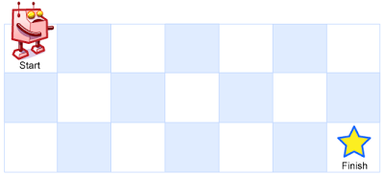

**Input:** m = 3, n = 7

**Output:** 28

**Example 2:**

**Input:** m = 3, n = 2

**Output:** 3

**Explanation:**

From the top-left corner, there are a total of 3 ways to reach the bottom-right corner:

1. Right -> Down -> Down

2. Down -> Down -> Right

3. Down -> Right -> Down

**Example 3:**

**Input:** m = 7, n = 3

**Output:** 28

**Example 4:**

**Input:** m = 3, n = 3

**Output:** 6

**Constraints:**

* 1 <= m, n <= 100
* It's guaranteed that the answer will be less than or equal to 2 * 109.